Trade Integration, Environmental Degradation, and Public Health in Chile:
Assessing the linkages

John Beghin
Brad Bowland
Sébastien Dessus
David Roland-Holst
Dominique van der Mensbrugghe

Summary

This paper uses an empirical simulation model to examine links between trade integration, pollution and public health in Chile. Using a general equilibrium framework, we synthesize economic, engineering, and health data in a way that elucidates this complex relationship and can support more coherent policy in all three areas. The basic tool of analysis is a 72-sector calibrated general equilibrium (CGE) model, incorporating monitoring functions for 13 effluent categories and a variety of mortality and morbidity indicators. While the methodology supports more general applications, present attention is confined to atmospheric pollution and health status in the Santiago metropolitan area.
The trade integration scenarios examined include Chile's accession to the NAFTA, MERCOSUR, and unilateral opening to world markets. The latter scenario induces substantial worsening of pollution and expansion of resource-based sectors, partly because it facilitates access to cheaper energy. NAFTA integration is environmentally benign in terms of pollution emissions. NAFTA accession, relative to other trade integration scenarios, actually reduces environmental damage. This results because trade diversion reduces reliance on cheap energy, unlike the other two trade integration scenarios.
We find that emissions of small particulates (PM-10), SO2, and NO2, have the strongest impact on local mortality and morbidity. These three pollutants appear to be complementary in economic activity. For several types of emissions, accession to the NAFTA appears to be environmentally benign. Integration via MERCOSUR and unilateral liberalization has a negative effect on the environment and upon urban morbidity and mortality. Damages due to rising morbidity and mortality are of similar magnitude and substantial. Integration based on unilateral trade liberalization induces damages equal to 13 percent of the income gains arising from the trade integration.
Our results strongly support the double dividend conjecture (environment and efficiency gains). Taxing air pollutants while reducing trade distortions and maintaining revenue neutrality induces net welfare gains from both reduced health damages and increased efficiency.
Introduction

The policy significance of trade and environment linkages has increased sharply in recent years, largely because of a higher profile in trade negotiations such as the Uruguay Round and the NAFTA. Among academic observers, a consensus has emerged that trade policy is not an adequate tool for environmental protection (Beghin et al. (1994)), but many other aspects of this linkage remain contentious issues and will remain central to the policy debate (Whalley).
Unfortunately, the empirical evidence to inform this debate is still scarce, and this scarcity motivates the present paper. In particular, we seek to quantify the direct and indirect effects of environmental taxes, including their revenue, cost, and output effects, as well as their interaction with trade policies and their incidence upon the environment, public health, and elsewhere in the economy. For fast-growing developing economies, greater outward-orientation holds great promise in terms of growth and efficiency. Pursuing this goal blindly, however, may jeopardize long-term prosperity because of the environmental costs of such a strategy. Hence, it is essential to assess the environmental impact of trade policy generally and trade liberalization in particular, and to examine how these might be better coordinated with environmental policies to mitigate environmental degradation.
Our paper makes several contributions. Firstly, we explicitly incorporate links from trade to environment to public health indicators, rather than simply measuring pollution incidence or other environmental variables. Secondly, this paper is empirical, and intended to strengthen the basis of evidence for the rapidly evolving policy debate on trade-environment linkages. The present paper gives empirical evidence for Chile, but the methodology can be extended to other countries. Using an applied general equilibrium model, we investigate the interactions between trade and environmental policies, focusing particularly on trade liberalization and coordinated policies of effluent taxation. We provide estimates of emissions for detailed pollution types at the national level, identifying patterns of pollution intensity that emerge with greater outward orientation. Although we estimate increased intensities for several pollutants when trade integration is undertaken without concurrent environmental taxes, none of these is alarming.
A second motivation for the present study is to make more tangible the linkages between economic, environmental, and public health indicators, building upon recent and current work on urban pollution and health in Santiago (World Bank (1994); Ostro et. al. (1995); O’Ryan (1994)). This is an essential step in support of policy formulation that takes more explicit account of economy-environment linkages. Past emphasis in this area has been on resource depletion, which is appropriate but seriously limited, since it omits more direct and immediate personal costs of environmental degradation. We quantify the incremental mortality and morbidity associated with combined economic and environmental polices and their monetary damages. Because its topology, local climate, and economic concentration make this urban area comparable to Mexico City and Jakarta, pollution in Santiago poses a major environmental challenge to Chilean policy makers, now and well into the next century.
In this context, we find that abatement of three air pollutants (small particulates, SO2, and NO2 (a determinant of ozone)) has the largest impact on mortality and morbidity and far outweighs the health benefits which might arise from abatement of other air pollutants in Santiago. We also find that Chile’s accession to the NAFTA, compared to unilateral trade liberalization, would reduce the emissions of many pollutants and have a relatively benign effect on urban public health. Unilateral integration, by contrast, would appear to induce a significant transfer of pollution capacity to Chile from the Rest of the World, adversely affecting the environment and public health. Here the case for coordination with environmental policy is compelling indeed.
Last, we provide new empirical insights on the double dividend hypothesis. The double dividend arises from revenue-neutral tax reform inducing two welfare gains: an environmental improvement through environmental taxes and a deadweight loss reduction from decreasing existing taxes to keep revenue constant. Several forms of the hypothesis exist (Goulder). Most of the empirical investigations of the double-dividend hypothesis abstract from considering trade distortion reductions and omit the utility gains from the improving the environment (Bovenberg and Goulder; and Espinosa and Smith (forthcoming) for an important exception). This omission is motivated by the hope to find evidence of the efficiency dividend, which would then be sufficient to establish a double dividend. Such evidence would also show that environmental reforms pay for themselves. The difficulty to quantify the environmental dividend may also have been a reason to omit it. The omission tends to bias the test of the hypothesis towards rejection. Our Chilean investigation is well suited for looking at the double-dividend conjecture. The policy reform scenarios considered in our analysis maintain tax revenue neutrality and we explicitly value the health benefits from mitigating air pollution. We look at several conjectures. First, we establish that imposing revenue-neutral environmental taxes on air pollution induces net welfare gains via reduction in health damages. We also find that the efficiency dividend is negative for these environmental reforms. Scaling income taxation back to offset the revenue increase coming from the environmental taxes induces a small decrease in real income. The inclusion of health damage reduction is pivotal to empirically establish net welfare gains of this type of taxation reform. Second, we find that revenue-neutral coordinated policy reforms, in which trade and environmental distortions are both reduced, are also welfare improving. Taxing air pollutants while reducing trade distortions and maintaining revenue neutrality, induces net welfare gains from reduced health damages. We establish a true double dividend (efficiency gains from the tax substitution and environmental health damages reduction).
Until 1975, Chile represented a textbook case of import-substitution, replete with trade distortions, slow growth, foreign exchange restrictions and resulting misallocation of resources. Following a series of policy reforms under the structural adjustment of the 1980s, Chile has become a thriving outward-oriented economy (Papageorgiou et al.; World Bank; ). Growth of output and exports has been spectacular in natural resource-based industries such as agriculture, fisheries, forestry, and mining sectors in which Chile has traditionally been competitive. These expansions have fostered rising living standards and concerns for the environmental consequences of the resource intensity of the growth (World Bank).
In parallel, urbanization is already well advanced in Chile, where about 85 percent of the population live in or within the vicinity of major cities (for example, Santiago Metropolitan Area and Valparaiso). The income growth and rapid urbanization have outpaced the development of infrastructures such as paved roads, public transportation equipment and sewage treatment systems. Several environmental problems in urban areas are linked to the poor road infrastructure and the use of untreated wastewater used in irrigated agriculture (World Bank (1994)).
The infrastructure problem exacerbates air pollution in Santiago by contributing to emissions of suspended particulates and other effluents in the air. This problem combined with unique topological and climatic conditions (thermal inversion) put Santiago in the league of the most-polluted cities in the world. Rising income and heath concerns are at odds with this situation. With the assistance of international organizations, Chile has started addressing these environmental problems, especially, air and water pollution in Santiago, and the depletion of forest resources but environmental regulation remains limited (Birdsall and Wheeler; World Bank (1994)).
A critical mass of information has recently been accumulated on urban pollution in Santiago (O'Ryan (1994); Sanchez (1992); Turner et al. (1993); and World Bank (1994)). We make use of this information when we link national pollution estimates to pollution concentrations in Santiago. Our study is a useful contribution to the existing work on Santiago for several reasons. It provides estimates of pollution emissions at the national level and of their variations induced by policy changes and linked them to ambient pollution in Santiago. Second, our valuation of the change in mortality in Santiago resulting from policy reforms is based on a willingness-to-pay approach (Bowland), which is more accurate than the World Bank’s human capital approach (World Bank (1994)). The latter merely serves as a lower bound on the value of a life saved, but it is not terribly informative.

The TEQUILA Model

The Trade and Environment eQUILibrium Analysis (TEQUILA) model is a prototype computable general equilibrium model developed at the OECD development Centre for research on sustainable development. The full model is described in details in Beghin et al. (1996) (provided to the editor). The TEQUILA model is recursive dynamic: each period is solved as a static equilibrium problem given an allocation of savings and expenditure on current consumption. The bulk of labor and capital income is distributed to the different households, and it is therefore possible to assess the distributional impacts of changes in both trade and environmental policies.
Households are assumed to maximize utility using the extended linear expenditure system (ELES). We assume that commodity and environmental consumptions are separable and that welfare consequences of reforms are the sum of the welfare effects in commodity markets and environmental health damages. The next section describes the salient features of the health module used to obtain environmental health damages.
The model is multi-sectoral (72 sectors for Chile) with careful disaggregation of pollution-intensive and natural-resource-based sectors. Natural resource activities include five agricultural sectors, forestry, fisheries, and five mining/extraction sectors. Twelve agricultural processing sectors, four wood-based sectors, four oil-based chemical industries, and eight mineral-based activities capture the linkages between natural resources and manufacturing.
Output is characterized by CRS technology and the structure of production consists of a series of nested CES functions. Final output is determined from the combination of (non-energy) intermediate inputs and a composite bundle of energy and value added (labor, and capital (machinery and land)). Non-energy intermediate inputs are assumed to be utilized in fixed proportions with respect to total non-energy intermediate demand. The energy-value-added bundle is further decomposed into a labor aggregate, and a capital-energy bundle. Labor demand is further decomposed into ten occupations. The capital-energy bundle is further disaggregated into capital demand and demand for an energy aggregate. The energy bundle is itself decomposed into four base fuel components. We use elasticity values in the multi-nesting of production decisions, from top nesting to bottom which reflect conventional wisdom on plausible parameter values for developing economies, (see Sadoulet and de Janvry, chapter 12). These values are conservative estimates and are motivated by our concern not to overstate abatement possibilities achieved through substitution away from dirty inputs and to be transparent in our model building. We use the following values: between intermediate consumption and aggregate value added made of old capital, 0; between intermediate consumption and aggregate valued added including new capital, 0.5; within value added and between aggregate labor and aggregate energy cum old capital, 0.12; between aggregate labor and aggregate energy cum new capital, 1; within aggregate labor, and between any two category of labor, 0.4; between aggregate energy and old capital, 0; between aggregate energy and new capital, 0.8; within aggregate energy combined with old capital and between any two types of energy inputs, 0.25; and finally between any two energy sources combined to new capital, 2.
Most existing economywide models investigating pollution issues assume fixed proportion between sectoral output and emissions associated with that sector (see for example Lee and Roland-Holst, Espinosa and Smith (1995)). By contrast, we posit substitution possibilities between value added, energy and non-energy intermediate goods, which allow the decrease of pollution associated with production if pollution taxes are put in place. This is a major improvement in the incorporation of pollution in economywide modeling. We econometrically estimate the pollution effluents by sector as being function of energy and input use (Dessus et al.). Estimates of these input-based effluents intensities are obtained by matching data from a social accounting matrix disaggregated at the 4-digit ISIC level to the corresponding IPPS pollution database of The World Bank (Martin et al.). Both the final consumption and the intermediate use of polluting goods generate emissions. Excise/effluent taxes are used to achieve pollution abatement. These taxes are measured as unit of currency per unit of emissions and are uniform taxes per unit of effluent for all sectors. Since every sector has different effluent intensities, the pollution tax, expressed per unit of output, varies across sectors.
A vector of 13 measures of various water, air and soil effluents characterizes pollution by sector. Pollution intensity varies by sector and with relative prices, since the use of “dirty” inputs is influenced by relative price changes induced by policy intervention. The 13 pollution measures include: toxic pollutants in water, air and land (TOXAIR, TOXWAT, TOXSOL); bio-accumulative toxic metals in air, soil, and water (BIOAIR, BIOWAT, BIOSOL); air pollutants such as SO2, NO2, CO2, volatile organic compounds (VOC), and particulate intensity (PART); and finally, water pollution measured by biological oxygen demand (BOD), and total suspended solids (TSS).
The model incorporates three closure rules. The government saving/deficit is assumed to be fixed in real terms which implies that some tax rate is endogenous to achieve this budget balance. We choose to have the household direct tax rates endogenous. Excess revenues are distributed by scaling these tax rates proportionally. The second closure rule is that investment is savings driven. Changes in saving levels (household, government, or foreign) will have a direct impact on the investment level. The final closure rule holds that the trade balance is fixed (in foreign currency terms). The impact of this closure rule is that a removal of trade distortions typically leads to a real depreciation, as increasing import demand must be matched rising exports at constant world prices.
There are three essential dynamic components in the TEQUILA model. The first is factor accumulation. Labor supply is assumed to grow exogenously, while the capital stock evolves with investment activity. The second element is productivity growth. There are efficiency factors for capital, labor (by each occupation), and energy. The efficiency factors are normally exogenous, but the capital efficiency factor is imputed in the benchmark simulation to achieve a specified trajectory of real GDP growth. The third element is a vintage capital assumption. The composition of the capital stock, which will determine the degree of flexibility in production, is be influenced by the time path of total and sectoral investment allocation.
We calibrate the TEQUILA model using a detailed social accounting matrix of Chile for 1992. The model is neoclassical with all markets reaching equilibrium. Trade is modeled assuming goods are differentiated with respect to region of origin and destination. On the import side, we account for the heterogeneity of imports and domestic goods with the CES specification attributed to Armington. We assume a CET specification for domestic output, in which producers are assumed to differentiate between the domestic and export markets. We assume that Chile is a small country. Trade distortions are expressed as ad valorem tariffs. This assumption is consistent with the recent tariffication of most trade distortions in Chile following its structural reforms.

The Santiago Health Module

This section outlines how we map predicted pollution emissions from our simulations into health effects for residents of Santiago, and then ascribe monetary damages to health impacts of pollution. A detailed description is provided upon request (appendix provided to editor). the model estimates the change in health status associated with a change in major air pollutants by each of 72 industrial activities in Santiago. Changes in industry emissions used are obtained from the economywide model. The health effects model transforms these emissions data into corresponding changes in health status (e.g., reduction in PM-10 related mortality). In so doing, the health-effects component is used to estimate the potential health damage savings (costs) corresponding to alternative trade and environment policy scenarios analyzed by the economywide model.
In characterizing emissions, we use baseline information on major air pollutants and emission sources. This step involves collecting data on pollutants known to cause significant health problems in Santiago, the corresponding emission sources, and baseline average annual emissions and ambient concentration levels. The data are used to estimate the portion of economywide emissions attributable to Santiago, as well as calibrate the health module of the CGE model to initial conditions.
Dispersion modeling maps effluent emissions into ambient concentration levels, and population-weighted concentration levels are used to determine exposure rates for health impacts. The next step involves calculating the health status response to changes in concentrations of air pollutants. Dose response functions express the change in incidence of mortality/morbidity induced by changes in pollution concentrations (Ostro et al.). The figures on health end-points presented in the results section should be interpreted as increases or decreases in mortality and morbidity with respect to the mortality and morbidity that would have prevailed at a predetermined safe standard of pollution concentrations. We look at various morbidity and mortality indicators: Premature mortality due to PM-10, SO2, and ozone; Premature mortality in males of age 40-59 due to lead; respiratory hospital admissions (for PM-10, ozone); emergency room visit (for PM-10); restricted activity days (for PM-10); lower respiratory illness for children population of age less than 17 (PM-10); asthma symptoms for asthmatic population (for PM-10, ozone); respiratory symptoms (for PM-10, ozone); chronic bronchitis in population of age 25 or older (for PM-10); minor restricted activity days (for ozone); respiratory symptoms in children population (for SO2); chest discomfort in adult population (for SO2); respiratory symptoms in adult population (for NO2); eye irritation in adult population (for ozone); number of headache in adult population (for CO); IQ decrement in children population (for lead); cases of hypertension in adult male population (for lead); and non-fatal heart attacks in male population age 40-59 (for lead).
The last step is to attach a monetary value to the health impact figures. We follow a willingness-to-pay approach to valuing morbidity and loss of life due to a change in mortality, relying on the large body of information and data on such measures for industrialized economies to econometrically estimate these damages for Chile. Damages due to mortality are based on the value of a statistical life, which indicates the aggregate valuation by individuals of reducing the risk of dying. For Santiago, our estimate is roughly .55 million dollars per life, in 1992 (purchasing power parity) US dollars. This estimate corresponds to the value of a life reached in 2010 evaluated at risk and income levels of the business-as-usual scenario (Bowland).
Because of the scarcity of corresponding morbidity estimates available for industrialized countries, our morbidity willingness-to-pay measures are less sophisticated. Available estimates from industrialized countries were simply scaled down to reflect the per capita income differences between Chile and these industrialized countries, expressed in (PPP) 1992 US dollars. The appendix provides the unit values used to value morbidity and mortality changes.

Policy Reform Scenarios

The time horizon of the simulations is the period 1992-2010. We first define a reference trajectory for the economy based on DRI-McGraw-Hill predictions of GDP growth until 2010. Factor and energy productivity changes are endogenously determined such that the GDP forecast and the model are consistent with each other. All policies are held constant in this reference scenario, called the business-as-usual (BAU) scenario. For the years 1992 to 2010, the model gives us reference trajectory base for output, absorption, trade, and pollution emissions, for this BAU scenario. This is the base or reference trajectory of the economy for our analysis. All reported results are expressed in deviations (in percent) from this BAU scenario and for 2010, which is the final year of the simulation exercise.
The first reform scenario imposes taxes on pollutants, one at the time. Each tax level is endogenous and is such that the emissions of the targeted pollutant progressively decrease over time and reach a 25 percent decrease relative to its level in the BAU results by 2010. The phasing in of these taxes is set to obtain gradual reductions of 10 percent in 1995, 15 percent in 2000, 20 percent in 2005, and 25 percent in 2010. The tax rates per unit of effluent are the shadow prices of the quantitative constraints on the pollution emissions.
The second scenario considers gradual trade integration, combining unilateral trade liberalization through tariff reduction vis-à-vis all trade partners, with a concurrent but modest improvement of terms of trade. Terms of trade are parametric for Chile, assumed to be a small country, and the terms of trade improvement is introduced as an exogenous shock to mimic transaction cost reduction resulting from integration. We assume that export prices increase to simulate this improvement that should result from the integration of trading countries. This is equivalent to an improvement of the terms of trade. Hence, our simulation results should not be read literally as estimates of the impact of trade liberalization under GATT obligations or other type of agreement. Rather, we want to replicate likely conditions resulting from integration and analyze its implications on specialization, pollution, real income and other variables of interest.
Specifically, we decrease the ad-valorem tariffs, progressively to zero, from their reference levels (1992) as 90 percent of original tariffs in 1995, 60 percent in 2000, 30 percent in 2005, and no tariff in 2010. Terms-of-trade improvements are expressed as an increase in observed world prices for exports by 2 percent in 1995, 4 percent in 2000, 7 percent in 2005, and 10 percent in 2010.
We consider analogous regional integration and liberalization scenarios with NAFTA and MERCOSUR countries. Disaggregated data on trade flows allow us to consider these alternative trade integration scenarios. In these two other trade scenarios, we remove tariffs and increase export prices following a similar progression as in the previous scenario, but only with respect to trading partners which are members of these two regional agreements. Our objective is to impose a sizable trade shock on the Chilean economy to estimate changes in sectoral composition of production and trade following a more selective trade integration. These changes determine the pollution emitted and induced by the outward trade orientation.
The last group of reform scenarios combines the first two types of reforms. For this last scenario, the objective is to investigate the implications of coordinated trade and environment policies. Analytical results (Copeland; and Beghin et al. (1997)) imply that the coordinated piecemeal approach -gradual changes of two instruments to correct for trade and environmental distortions- leads to welfare improvements. In the context of joint trade and environmental reforms, efficiency gains are obtained because trade distortions are reduced and because environmental degradation can be reduced as well. Recall we want to investigate the effect of such joint reform on sectoral allocation, trade, and pollution abatement. When border distortions have been removed (domestic border prices are equal to world prices) the incentives to change input mixes to abate pollution in production have been altered, compared to the case of the single environmental reform. The differences in the incentive structures lead one to expect contrasting results concerning the indirect abatement achieved via complementarity and substitution among emission types, which occurs under the two scenarios.

Results from Policy Reform Simulations

Results follow the sequence of the three reform scenarios: environmental tax reform, trade integration (unilateral, NAFTA, and MERCOSUR), and then combined trade integration and environmental protection. Results are presented for the final year, 2010, in percent deviations from their BAU values. Table 1 summarizes the salient results of the simulations in aggregate. Table 2 shows the effects of the various scenarios on pollution emissions. We first note some stylized facts emerging from the Social Accounting Matrix on sectors which appear to be pollution hot-spots in Chile. The following sectors exhibit high intensities and levels for several effluent types: agriculture, sugar refining, mining, chemicals, metals, pottery, electricity, gas, and transportation sectors.

Effluent taxes
Effluent taxes have a small negative impact on growth except for the tax on bio-accumulative emissions released in water (BIOWAT), which has a larger impact (an 8.1 percent decrease in GDP over 18 years with respect to what it would have been under BAU). Hence, this negative real income effect indicates that environmental reforms “do not pay” for themselves in the narrow efficiency sense of the double-dividend conjecture. There is a real efficiency cost involved in the implementation of the environmental reforms. The effects of these taxes on other aggregate measures of economic activity tend to be small as well, with the same exception of the tax on BIOWAT. Trade decreases by about 10 percent and investment decreases by 23 percent. The moderate aggregate output effect of the environmental taxes is a result from aggregation. It dissimulates substantial variations at the disaggregated sectoral level and reallocation of resources across sectors.
Next we look at noticeable sectoral output effects, i.e., substantial changes in output occurring in some of the 72 disaggregated sectors included in the model. For the first four taxes (all three toxics, BIOAIR), fish and seafood output increase significantly (increases of 60 to 193 percent). For the same effluent taxes, mining activities decrease sharply (-17 to -60 percent). The tax on BIOWAT, which induces the largest decrease in aggregate output, has a negative effect on virtually all sectors, and it especially has a strong effect on iron, coal, and basic metals (-30 to -59 percent). Trade contracts with the effluent taxes. At the disaggregated sectoral levels, trade effects are mixed (some decreases, some increases) and moderate.
The simulation results indicate that the impact of the taxes on pollution abatement is diverse. Strong complementarities are observed in several subsets of the 13 effluent types, despite the clear possibility of substitution among pollution emissions implied by our model since we do not impose any fixed proportions between output and emissions. An increase in the tax on one effluent induces a decrease in another effluent level. All toxics are such a group, so are all bio-accumulative emissions, and NO2, SO2 and PART (PM-10). The larger subset of toxics and bio-accumulative emissions follows such a pattern. More intriguing is the presence, in the aggregate, of substitution possibilities among effluents. For example, SO2 and NO2 are substitutes for TSS and for bio-accumulative emissions in air and soil.
The tax rates implied by the targeted decrease in emissions are realistic, when expressed in ad valorem equivalent of the producer price. On average. the pollution tax per unit of sectoral output is 4 percent or less for all 13 scenarios. The individual tax rates (per sector and by effluent) vary from zero to less than 15 percent for all 13 scenarios, except for the scenario targeting reduction in VOC. In the latter scenario the pollution tax rate on wine and liquors jumps to 52 percent, and the corresponding tax rate on furniture products is 37 percent. These high rates are caused by the fact that these two sectors account for most of the VOC pollution in production.
The decomposition of pollution abatement by source, following Copeland and Taylor’s decomposition into scale (aggregate output expansion), composition (composition of GDP), and technique (input substitution) effects, reveals interesting results. First, the composition effect seems overwhelming both in the abatement in production and consumption. The effect is more substantial in production than in consumption, that is, imports substitute for domestic output in pollution-intensive sectors. The technical effect in production is moderate, and the scale effect is marginal for most pollutants except for the case of the tax on BIOWAT (production scale effect of -8.1 percent). Surprisingly, a few simulations exhibit positive scale effects in production abatement (all toxics, BIOAIR, BIOSOL, and BOD). Since the scale effect is the aggregation of sectoral output effects over all sectors, the latter result may be due to the expansion of activities that are not intensive in the pollutants being taxed. This expansion, weighted by prices, outweighs the decrease in output in polluting sectors. For instance, the taxes on all three toxics decrease toxic-intensive industries such as mining and metallic industries, but stimulate fisheries and seafood, and forestry and wood products.
This example shows the limitation of tackling environmental degradation by a single pollution effluent at the time. Abatement of one effluent gives rise to an increase in resource-intensive activities such as forestry and may induce additional degradation and welfare losses if externalities are present in these sectors. This result reinforces our finding that targeting one specific pollutant group can have unintended and damaging consequences on emissions of “substitute” pollutant groups, and calls for an integrated approach to the design of environmental policies (all emissions, natural resource extraction).
In addition, the decomposition of abatement sheds light on the substitutability between effluents. A variety of patterns emerges. Substitution between two effluent types occurs when all three effects are positive (for example, TSS response to tax on TOXWAT), or when two or less out of the three effects are positive and larger in magnitude than the remaining effect(s) (for example CO2 response to BOD tax).
The impact of the effluent taxes on the concentration in Santiago is diverse and to some extent, follows the complementarity/substitution patterns observed for emissions. As shown in Table 2, all three toxic taxes provide significant decreases in lead (about 10 percent), but nothing else, except for a slight increase in CO concentration (1.1 percent). The three bio-accumulative pollution taxes decrease lead concentrations as well (by 10 to 20 percent). The tax on BIOWAT has negative and sometime large effects on other concentrations as well -remember it is the tax which has the largest negative scale effects among the effluent taxes. Air pollution taxes also produce similar concentration patterns. Emission taxes on either NO2, SO2, or PM-10 leads to a substantial decrease in the other two (averaging about 19 percent), and some decrease in CO (averaging about 5 percent). Taxes on CO and VOC also achieve substantial decreases in concentration in Santiago. The taxes on water pollution (BOD, TSS) have marginal impact on most of the concentrations.
As shown in Table 3, the health endpoint changes are striking for the taxes on SO2, NO2, and PM-10. Premature mortality due to PM-10, SO2 and ozone decreases by more than 30 percent. With these three taxes, most endpoints show improvements with decreases of morbidity of about 30 percent for seven of the morbidity measures. There is a marginal deterioration of morbidity incidence linked to lead (about 1 percent). This result is the consequence of the slight increase in BIOAIR emissions induced by the taxes on SO2 and NO2 (around 4 percent).
Table 4 presents the health damages reduction induced by the environmental taxes. Figures within parentheses indicate a reduction in damages. The tax on PM-10 induces a decrease in monetary damages equivalent to .82 percent of the BAU 2010 GDP; taxes on SO2 and NO2 reduce damages by an amount equivalent to .65 percent of BAU 2010 GDP. The latter taxes induce net gains or a double dividend, as approximated by the loss of aggregate income plus the reduction in damages. These results show the importance of accounting for nonmarket benefits when considering the impact of environmental taxes. The estimated welfare gains are lower-bound estimates because the decreases in morbidity and mortality are only applied to Santiago’s population. As suggested by the table some taxes, such as the tax on VOC, induce negligible net gains in welfare. Hence, we find evidence of a net dividend –when accounting for health damages environmental reform can pay for themselves-, but the latter is rather small in part because we only value health benefits for a subset of the Chilean population.

Trade Integration
To summarize, we look at two types of trade integration leading to three scenarios: with the world (unilateral integration), and regional integration (NAFTA, and MERCOSUR). Unilateral integration induces the largest increase in GDP (+5.6 percent), followed by NAFTA (1.4 percent) and MERCOSUR (0.6 percent). These gains are small -they represent the relative gains over 18 years. These small changes originate in the outward-orientation Chile has been following; large gains from liberalization have already occurred. Nevertheless these reforms have more significant positive impacts on aggregate trade and aggregate gross investment.
Moving to disaggregated sectoral output effects, the three trade reforms exhibit sharp contrast. The unilateral trade reform stimulates the output of fruit, forestry, iron, other mining, food processing, wood products, paper, and petroleum refining. Conversely, petroleum and gas production, chemicals, glass and other manufacturing contract with undistorted trade. With NAFTA integration, fruit, agricultural services, other mining, food processing, wine and liquor, would expand significantly, whereas copper, iron, and paper would decrease. Hence, NAFTA integration departs significantly from integration with all partners in terms of international specialization. MERCOSUR integration does not induce any strong effect, except for a major increase in transportation material and a decrease in fish and seafood production.
The trade effects of these reforms are as follows. The unilateral reform induces major increases in virtually all sectoral imports and exports, except for imports of chemicals, glass, and other manufacturing. NAFTA integration has a smaller effect on trade than unilateral reform, except for noticeable increases in imports of agriculture and sugar, and smaller increases for livestock, forestry, fish, mining sectors, sugar, wood products, furniture, paper, and plastic; exports of fruits, mining (other than copper, coal, and iron), dairy, wine and liquor, furniture, and pottery. Finally, the MERCOSUR integration induces increases in imports of agricultural products, iron, oils, sugar, tobacco, petroleum refining, and metals; imports of fish would decrease. On the export side, substantial reductions occur in exports of fish, iron, and seafood; but food processing, chemicals, plastics, and printing expand significantly.
The pollution implications of these trade reforms are contrasting. Unilateral integration is pollution intensive, e.g., NO2, SO2, and PM-10 have an elasticity of 3.5 with respect to GDP increases induced by this unilateral reform. By contrast, MERCOSUR and NAFTA have elasticity values around 2.7 and 2.2 respectively, for the same effluents. NAFTA integration induces decreases in several pollutants (the three toxics, BIOAIR, BIOSOL, and BOD). MERCOSUR induces a decrease in TSS only. The trade diversion of NAFTA integration provides a significant environmental benefit in terms of mitigated emissions, relative to other two trade integration scenarios. This is an unexpected if not overlooked insight on trade diversion in presence of externalities. The decrease in effluents under the NAFTA scenario is achieved through strong composition effects in production, outweighing the scale expansion induced by NAFTA. By contrast, the unilateral integration vis-a-vis all partners induces higher intensities in SO2, NO2, and PART (PM-10) via strong technical effects towards pollution-intensive input combinations.
Still under unilateral integration, we observe marginal increases for all toxics, BIOAIR, CO2, VOC, and BOD; we have marginal decreases for TSS, and BIOSOL. Finally, we see substantial increases for PM-10, SO2, and NO2. These increases are observed after 18 years of expected growth and hence do not represent anything dramatic. By contrast, NAFTA membership induces decreases in pollution intensity of GDP or production. This difference between the two trade reforms is caused by the cheap energy import occurring under the unilateral trade reform scenarios, but not under NAFTA.
For the health end-points in Santiago, the unilateral integration scenario has negative consequences for both mortality and almost all measures of morbidity. Premature mortality due to PM-10, ozone, and SO2 increases by 25 percent and premature death in males of age 40-59 due to lead increases by 9.2 percent, as shown in Table 3. Morbidity increases range from 9 percent for cases of hypertension and non-fatal heart attacks to about 26 percent for chest discomfort episodes and respiratory symptoms in children. NAFTA and MERCOSUR induce marginal increases in the health end-points. Although NAFTA decreases several types of emissions, these decreases do not translate into major gains for urban health because these improvements are not relevant for air pollution in Santiago, except for a small improvement in lead concentration. The damages associated with the health incidences are substantial for the unilateral trade integration. As suggested by Table 4, the damages represent 13 percent of the aggregate income gains induced by trade integration (damages as percent of gains in GDP). By contrast the damages under the NAFTA scenario are moderate due to the small deterioration of the average health status in Santiago.

Trade Integration Combined with Environmental Protection
In this last set of reforms, we first combine NAFTA integration and effluent taxes on a subset of pollutants (air pollutants). Then, we consider the integration via unilateral trade integration coordinated with effluent tax on one pollutant at the time. The effluent taxes are designed as in the first set of scenarios on environmental reforms (incremental and leading to a 25-percent decrease in emissions of the taxed effluent with respect to their BAU levels). The tax rates corresponding to these reforms are slightly higher than in the environmental reforms alone. The average tax rates on pollution, expressed in percent of the producer price per unit of output, do not exceed 5.8 percent. With trade integration, the pollution expansion requires higher tax rates than those reached under the environmental reform alone, in order to go back to a pollution level corresponding to a 25 percent decrease with respect to the BAU level. As an additional consequence of these higher rates, substitution/complementarity relationship between pollutant types are exacerbated.
The aggregate effect of the combined reforms (NAFTA cum effluent tax) is small in general, but it is positive on real income in all cases. Back to the double dividend conjecture, this positive real income effect suggests that with this larger policy menu (trade and environmental distortions), the environmental reform pays for itself, even when one abstracts from the associated health benefits. The aggregate effects also differ according to the pollutant considered. For example, the effluent tax on CO2 has practically no effect on aggregate measures, whereas, the tax on VOC has a negative impact on production, consumption. The pollution abatement figures, including the multiplier effects of the tax on pollutants that are not directly targeted by the tax, are surprisingly similar to the abatement figures for the reforms limited to environmental reforms alone. The abatement on the targeted emission is of course exactly similar by design, but the indirect abatement of the other pollutants does not have to be because relative prices are different under the two scenarios. The result is surprising because changing border prices affects specialization and hence pollution. This result is due to the fact that NAFTA integration has a mitigated impact on the Chilean environment.
The impact of coordinated reforms –unilateral trade integration cum environmental taxes- appears almost additive on aggregate output, trade and consumption: the aggregate effect of the coordinated approach is the sum of aggregate effect of the two individual reforms. This is a recurrent result in this type of simulation exercise (Lee and Roland-Holst; Beghin, Roland-Holst and van der Mensbrugghe (1995)). However, with respect to the double dividend issue, not all scenarios lead to an environmental benefit and here this additivity breaks down. This result is caused by substitution among emissions groups which are exacerbated when trade distortions are removed. A tax on one pollutant group increases emissions of another pollutant group and associated health damages. The scenarios involving unilateral trade integration and a tax on BIOWAT, SO2 ,NO2 ,VOC and PART (PM10), induce an environmental dividend. The other combined scenarios do not.
Aggregate trade expands less under the coordinated reforms than under the simple unilateral trade integration, although some sectoral import induced by the latter reform, grow even more under the coordinated scenario because imports are a way to abate pollution. For instance, imports of fish are larger under the combined scenario than under the unilateral trade integration scenario.
The inventory of emissions shown in Table 2 tends to duplicate the patterns reached under the single effluent tax reform since we target the amount of pollution in a similar fashion (-25 percent for each effluent type). Nevertheless, the substitution between bio-accumulative and toxic pollutants as a group and the air pollutants (SO2, NO2, VOC, PM-10, and CO2) as another group is amplified by trade integration. This increased substitution is caused by a selective increase in pollution dictated by the change in relative prices of pollutants when only one type of pollutant is taxed.
In Table 3, the urban health impact of the coordinated reforms reflects these stronger substitutions between broad groups of pollutants. Mortality due to air pollution increases dramatically under the combined scenarios involving bio-accumulative and toxic pollution, because the emissions of PM-10, SO2, and NO2 are stimulated. Similarly, the morbidity induced by SO2, NO2, PM-10 and CO increases under the same combined scenarios. The VOCs-ozone increases have a negative effect on many morbidity measures: increase in restricted activity days, in the number of asthma attacks, respiratory symptoms, in minor restricted activity days, and in eye irritation cases. As shown in the last part of Table 4, damages reductions under coordinated reforms are less substantial than under the environmental tax alone, because of the substitution forces at work among pollutant types. This last result was commented on earlier on. When we compare the combined reforms to the unilateral trade integration reform alone, all combined scenarios exhibit higher real income levels, inclusive of the health damages. For example, the tax on PM-10 combined to unilateral trade integration induces net welfare gains which are 14 percent higher than the net gains under trade integration alone.

Conclusions

This paper seeks to elucidate linkages between trade, environment, and public health status in an outward-oriented economy. From our results, it is apparent that such linkages are quite complex, and policy makers relying on intuition alone are unlikely to achieve anything close to optimality. Policies in all three areas are clearly interdependent, and better coordination could reduce the social and economic costs of economic growth and environmental mitigation. More detailed empirical work is needed, however, to support such policies.
Trade integration scenarios offer different outcomes in terms of growth, international division of labor and environmental consequences. Integration into NAFTA is relatively benign to the environment and has the smallest pollution elasticity with respect to the trade-induced growth. World trade integration via unilateral trade liberalization, with no pollution abatement policy, induces higher growth and patterns of specialization more adverse towards the environment, leading to detrimental impacts on public health in Santiago and considerable monetary damages associated with the negative health impact. MERCOSUR simulations do not indicate substantial changes in income, pollution or public health, except for increased emissions of bio-accumulative pollutants, and small increases in mortality and morbidity linked to lead pollution in Santiago.
Considering effluent taxes alone, the abatement of three pollutants, SO2, NO2, and PM-10 achieves the largest decrease in both mortality and morbidity in Santiago. The health damage reduction exceeds the foregone aggregate real income and corresponds to a net welfare gain to the Chilean economy. Coordinated scenarios are well-grounded in economic theory and represent the best of both worlds (efficiency gains from trade, and protected environment); they are characterized by economic expansion and decreases in the emissions of the targeted pollutant as well as its polluting “complements”. Nevertheless, emissions of untaxed substitute pollutants increase considerably. These strong substitutions have a negative impact on urban health, with notable increases in mortality and morbidity when toxic and bio-accumulative pollutants are the targets. Further, several natural-resource based sectors expand as well, hence increasing the dimensionality of policy coordination (trade policy, effluent taxes, natural resource management). This is a result specific to our investigation of Chile. By contrast, our analysis of trade and environment linkages in Mexico suggests mostly complementarity between effluent types (Beghin et al. (1995)) .
The observed substitutability among pollutant types and its implications for urban health raises two additional coordination and targeting issues. The first one is the coordination of environmental programs targeting subgroups of pollutants (e.g., toxic, bio-accumulative, air criteria pollutants). Given the substantial substitutability between these groups, an integrated approach to environmental reform encompassing all major groups of pollutants appears appropriate to avoid unintended environmental degradation or negative health consequence.
The other issue is the hopeful observation that strong complementarities exist within some groups of pollutants and that a policy targeting any pollutant within a group would achieve substantial abatement in most emission types included in the group. This finding is common to most of our case studies and emerges as an empirical regularity in these linkages.
Another regularity shared by this study and the other case studies using the same methodology is the relatively low cost of pollution abatement in terms of foregone aggregate income. In this specific case of Chile and Santiago, we establish this result in terms of welfare. The monetary damages equivalent to the health impact of air pollution are greatly reduced by environmental taxes, especially by the tax on PM-10, NO2, and SO2 , such that the these welfare gains exceed the loss of GDP induced by the taxes. A net welfare gain emerges. This statement should be qualified because the resource reallocation implied by the effluent taxes is substantial on a sectoral basis and we do abstract from explicit adjustment cost.
The observed substitutability among pollutant types raises two additional coordination and targeting issues. The first one is the coordination of environmental programs targeting subgroups of pollutants (e.g., toxic, bio-accumulative, air criteria pollutants). Given the substantial substitutability between these groups, an integrated approach to environmental reform encompassing all major groups of pollutants appears appropriate to avoid unintended environmental degradation. The other interesting point is the hopeful observation that strong complementarities also exist within some groups of pollutants and that a policy targeting any pollutant within a group would achieve substantial abatement in most emission types included in that group.
Last, we provide new empirical insights on the double dividend hypothesis, especially in the neglected context of open economies and trade distortions. We find that revenue-neutral environmental taxes on air pollution induce health benefits which are larger than the net efficiency loss induced by these new taxes. Second, we establish that revenue-neutral coordinated policy reforms, in which trade and environmental distortions are both reduced, constitute a double-dividend with both substantial efficiency and environmental gains in the case of air pollution in Chile. In the latter context, reducing PM-10, NO2, and SO2 combined with a removal of trade distortions, induces both efficiency and environmental benefits.

References

Beghin, J., D. Roland-Holst, and D. van der Mensbrugghe, "Trade and Pollution Linkages: Piecemeal Reform and Optimal Intervention," Canadian Journal of Economics, XXX (1997):442-455.

Beghin J., S. Dessus, D. Roland-Holst, and D. van der Mensbrugghe. "Prototype CGE Model for the Trade and the Environment Program. Technical Specification." OECD Development Centre Technical Papers No 116, Paris, 1996.

Beghin, J., D. Roland-Holst, and D. van der Mensbrugghe, "Trade Liberalization and the Environment in the Pacific Basin: Coordinated Approaches to Mexican Trade and Environment Policy," American Journal of Agricultural Economics 77 (1995): 778-785.

Beghin J., D. Roland-Holst, and D. van der Mensbrugghe. "The Trade and Environment Nexus. Global Dimensions" OECD Economic Studies 23 (winter 1994): 167-92.

Birdsall, N., and D. Wheeler. “ Trade Policy and Industrial Pollution in Latin America” Where are the Pollution havens?” in P. Low ed. (1992), op citum: 159-168.

Bovenberg, A.L., and L.H. Goulder. “Optimal Environmental Taxation in the Presence of Other Taxes: General Equilibrium Analyses,” American Economic Review 86 (1996): 985-1000.

Bowland, B.J. “Marginal Benefits of Trade and Environmental Policy: Valuing Air Pollution and Health in a Developing Country.” Thesis. North Carolina State University, Raleigh, 1997.

Dessus, S., and M. Bussolo. “Is There a Trade-off between Trade Liberalization and Pollution Abatement? A Computable General Equilibrium Assessment Applied to Costa Rica,” Journal of Policy Modeling 20 (1998): 11-31.

Copeland, B.R., "International and the Environment: Policy Reform in a Polluted Small Open economy," Journal of Environmental Economics and Management 20 (1994): 44-65.

Copeland, B.R., and M.S. Taylor. “North-South Trade and the Environment,” Quarterly Journal of Economics 109 (1994): 755-87.

Dessus, S., D. Roland-Holst, and D. van der Mensbrugghe. “Input-based Estimates for Environmental Assessment in Developing Countries,” OECD Development Centre Technical Papers No 87, Paris, August 1994.

Eskeland, G.S., and A.E. Harrison. “Moving to Greener Pastures? Multinationals and the Pollution-Haven Hypothesis.” Policy Research Working Paper No 1744, The World Bank, Washington D.C.,1997.

Espinosa, J. A., and V.K. Smith. “ Measuring the Environmental Consequences of Trade Policy: A Nonmarket CGE Analysis,” American Journal of Agricultural Economics 77 (1995): 772-77.

Espinosa, J.A., and V.K. Smith. “Using the Revised MECModel to evaluate the Double Dividend of Environmental Taxes,” forthcoming presentation at the 1998 Southern Economics Association Meetings.

Goulder, L.H. “Environmental Taxation and the ‘Double Dividend’: A Reader’s Guide.” International Tax and Public Finance 2 (1995):157-83.

Grossman, G.M., and A.B. Krueger. “Environmental Impact of a North American Free Trade Agreement,” CEPR Discussion paper 644 (1992), London.

Hettige, H., R.E.B. Lucas, and David Wheeler. “The Toxic Intensity of Industrial Production: Global Patterns, Trends and Trade Policy,’ American Economic Review Papers and Proceedings 82 (1992): 478-481.

Lee, H. and D. Roland-Holst. ”The Environment and Welfare Implications of Trade and Tax Policy,” Journal of Development Economics 52(1) (1997): 65-82.

Low, P. (ed.). International Trade and the Environment. World Bank Discussion Paper No 159, Washington D.C., 1992.

Low, P. and A. Yeats. “Do Dirty Industries Migrate?” in P. Low ed., (1992), Op Citum, 89-104.

Martin, P., D. Wheeler, M. Hettige, and R. Stengren, "The Industrial Pollution Projection System: Concept, Initial Development, and Critical Assessment," mimeo, The World Bank, 1991.

O’Ryan, R.E. “Cost Effective Policies to Improve Urban Air Quality in Developing Countries: Case Study for Santiago, Chile.” Thesis. University of California, Berkeley, 1993.

Ostro, B., J.M. Sanchez, C. Aranda, and G.S. Eskeland. “Air Pollution and Mortality: Results from Santiago, Chile.” Policy Research Working Paper (No. 1453). The World Bank, Washington D.C, 1995.

Papageorgiou, D., A.M. Choksi, and M. Michaely. Liberalizing Foreign Trade in Developing Countries. The Lessons of Experience. World Bank Publications, Washington D.C., 1990.

Sadoulet, E., and A. de Janvry. Quantitative Development Policy Analysis. Baltimore: The Johns Hopkins University Press, 1995.

Sanchez, J. M. "The Costs of Urban Pollution: The Case of Santiago," ILADES/Georgetown University, 1992.

Tobey, J. “The Effects of Domestic Environmental Policy on Patterns of World Trade: An Empirical Test,” Kyklos 43 (1990): 191-209.

Turner, S.H., C.S. Weaver, and M.J. Reale. "Cost and Emissions Benefits of Selected Air Pollution Control Measures For Santiago, Chile," Final Report Submitted to The World Bank. Engine, Fuel, and Emissions Engineering, Inc: Sacramento, CA, 1993.

Whalley, J. “Trade and Environment Beyond Singapore.” NBER Working Paper N0 5768, Cambridge, MA, September 1996.

World Bank. "Chile: Managing Environmental Problems. Economic Analysis of Selected Issues.” Report No. 13061-CH, Washington D.C., 1994.

Table 1 Impact of Policy Reform on Aggregate Variables

 | Environmental Reform: Aggregate Abatement of 25% by Type of Effluent Emission
Aggregate Variables | toxair | Toxwat | Toxsol | bioair | Biowat | biosol | so₂ | no₂ | CO₂ | voc | part | bod | tss
Real GDP | -0.7 | -0.8 | -0.7 | -0.3 | -8.1 | -0.3 | -0.2 | -0.2 | -0.1 | -0.4 | -0.3 | -0.7 | 0.0
Production | 0.4 | 0.3 | 0.3 | 0.3 | -8.1 | 0.4 | -2.4 | -2.4 | -0.8 | -3.0 | -2.6 | 0.3 | -0.1
Consumption | -0.4 | -0.5 | -0.4 | 0.0 | -1.6 | 0.0 | -1.3 | -1.3 | -0.2 | -1.8 | -1.3 | -0.4 | 0.0
Investment | -2.1 | -2.6 | -2.2 | -0.8 | -23.2 | -0.7 | -1.3 | -1.3 | -0.4 | -2.0 | -1.5 | -2.3 | -0.1
Exports | -1.6 | -1.9 | -1.7 | -1.0 | -10.2 | -0.8 | -3.1 | -3.1 | -0.6 | -2.1 | -3.2 | -1.7 | 0.0
Imports | -1.2 | -1.4 | -1.3 | -0.7 | -9.6 | -0.5 | -3.0 | -3.0 | -0.5 | -1.7 | -3.1 | -1.3 | 0.0
Labor Supply | -0.2 | -0.3 | -0.2 | -0.1 | -3.1 | -0.1 | 0.2 | 0.2 | 0.0 | -0.1 | 0.2 | -0.2 | 0.0
Capital Supply | -0.9 | -1.1 | -0.9 | -0.4 | -10.4 | -0.3 | -0.6 | -0.6 | -0.2 | -0.7 | -0.7 | -1.0 | 0.0
Real Income | -0.3 | -0.5 | -0.4 | 0.0 | -1.3 | 0.0 | -1.2 | -1.2 | -0.1 | -2.5 | -1.2 | -0.4 | 0.0
Absorption | -0.8 | -1.0 | -0.8 | -0.2 | -7.1 | -0.2 | -1.2 | -1.2 | -0.2 | -1.7 | -1.2 | -0.8 | 0.0

 | Trade Policy Reformª |  |  |  |  | Combined NAFTA and Environmental Policy Reform^{b}
Aggregate Variables | unilateral |  | Nafta | Mercosur |  | Bioair | so2 |  | no₂ |  | co₂ | voc | part
Real GDP | 5.6 |  | 1.4 | 0.6 |  | 1.2 | 1.2 |  | 1.2 |  | 1.4 | 0.9 | 1.1
Production | 7.3 |  | 1.6 | 0.6 |  | 1.8 | -1.1 |  | -1.1 |  | 0.7 | -1.8 | -1.4
Consumption | 9.2 |  | 2.1 | 0.9 |  | 2.1 | 0.6 |  | 0.6 |  | 1.8 | -0.1 | 0.6
Investment | 17.7 |  | 4.3 | 1.8 |  | 3.5 | 2.7 |  | 2.7 |  | 3.7 | 1.9 | 2.4
Exports | 18.0 |  | 3.6 | 2.7 |  | 2.7 | 0.1 |  | 0.1 |  | 2.9 | 1.2 | -0.1
Imports | 29.1 |  | 6.0 | 3.9 |  | 5.3 | 2.4 |  | 2.4 |  | 5.3 | 3.9 | 2.3
Labor Supply | 2.0 |  | 0.8 | 0.2 |  | 0.7 | 1.0 |  | 1.0 |  | 0.8 | 0.6 | 1.0
Capital Supply | 7.2 |  | 1.7 | 0.7 |  | 1.4 | 1.1 |  | 1.1 |  | 1.5 | 0.9 | 0.9
Real Income | 8.6 |  | 2.0 | 0.8 |  | 2.1 | 0.6 |  | 0.6 |  | 1.9 | -0.9 | 0.6
Absorption | 10.5 |  | 2.4 | 1.0 |  | 2.3 | 1.1 |  | 1.1 |  | 2.2 | 0.5 | 1.0
ªReflects unilateral trade liberalization, NAFTA integration and MERCOSUR integration by 2010 with no explicit environmental policy reforms.
^{b}Reflects combined policy reforms of NAFTA integration and aggregate abatement of 25% by type of effluent emission.
Table 1 (continued)
 | Unilateral Trade with Aggregate Abatement of 25% by Type of Effluent Emission
Aggregate Variables |  | toxair | Toxwat | toxsol | bioair | biowat | biosol | so₂ | NO₂ | co₂ | voc | part | bod | tss
Real GDP |  | 4.7 | 4.4 | 4.7 | 5.3 | -7.4 | 5.4 | 5.2 | 5.2 | 5.5 | 4.9 | 5.0 | 4.7 | 5.6
Production |  | 7.8 | 7.5 | 7.8 | 7.9 | -5.9 | 7.9 | 2.9 | 2.9 | 5.5 | 2.4 | 2.5 | 7.8 | 7.1
Consumption |  | 8.7 | 8.4 | 8.7 | 9.1 | 6.3 | 9.1 | 6.7 | 6.7 | 8.6 | 6.0 | 6.7 | 8.6 | 9.2
Investment |  | 14.4 | 13.3 | 14.4 | 16.9 | -21.9 | 17.1 | 14.9 | 14.9 | 16.6 | 13.9 | 14.5 | 14.3 | 17.6
Exports |  | 16.4 | 15.9 | 16.4 | 17.0 | 0.2 | 17.5 | 11.7 | 11.8 | 16.2 | 13.5 | 11.6 | 16.3 | 17.9
Imports |  | 27.9 | 27.4 | 27.9 | 28.3 | 10.5 | 28.9 | 22.2 | 22.3 | 27.3 | 24.7 | 22.2 | 27.9 | 29.1
Labor Supply |  | 1.7 | 1.7 | 1.7 | 1.8 | -2.9 | 1.9 | 2.4 | 2.4 | 2.2 | 1.9 | 2.3 | 1.7 | 2.0
Capital Supply |  | 6.1 | 5.7 | 6.0 | 6.9 | -9.6 | 6.9 | 6.2 | 6.2 | 6.9 | 6.0 | 6.0 | 6.0 | 7.2
Real Income |  | 8.2 | 7.9 | 8.1 | 8.6 | 6.1 | 8.6 | 6.2 | 6.3 | 8.2 | 4.4 | 6.3 | 8.1 | 8.6
Absorption |  | 9.3 | 8.8 | 9.3 | 10.3 | -1.8 | 10.3 | 8.2 | 8.2 | 9.9 | 7.5 | 8.1 | 9.3 | 10.5

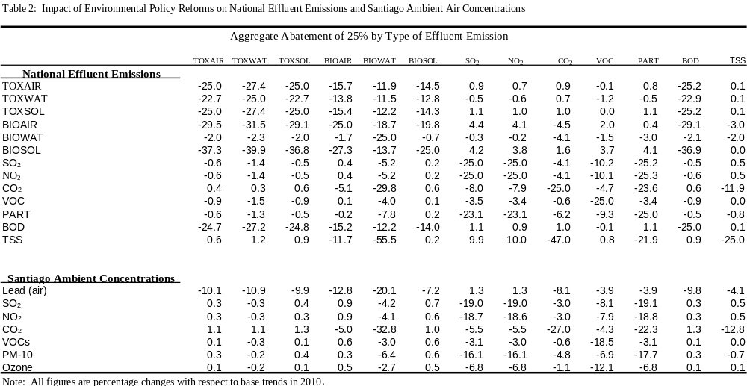
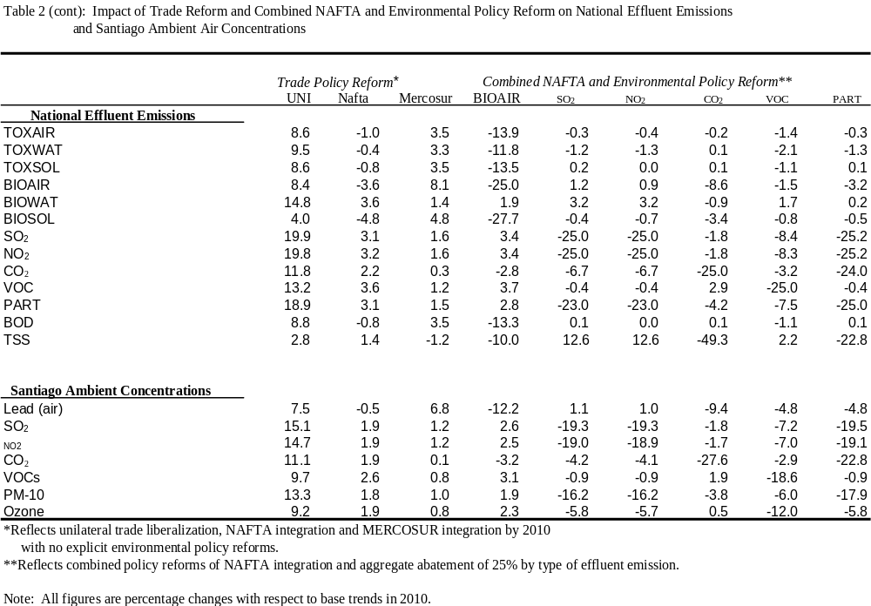
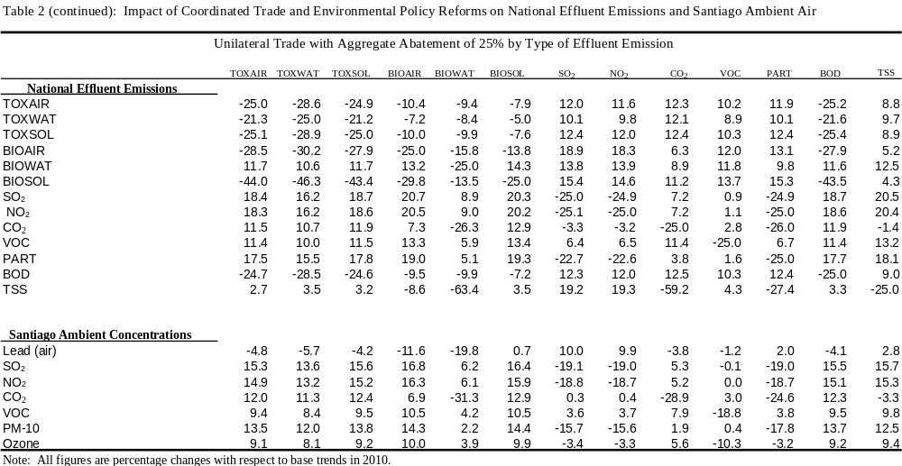

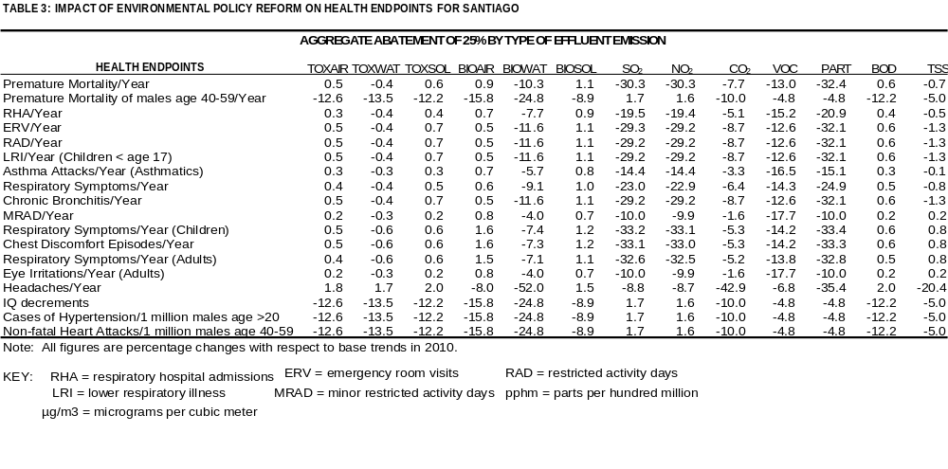

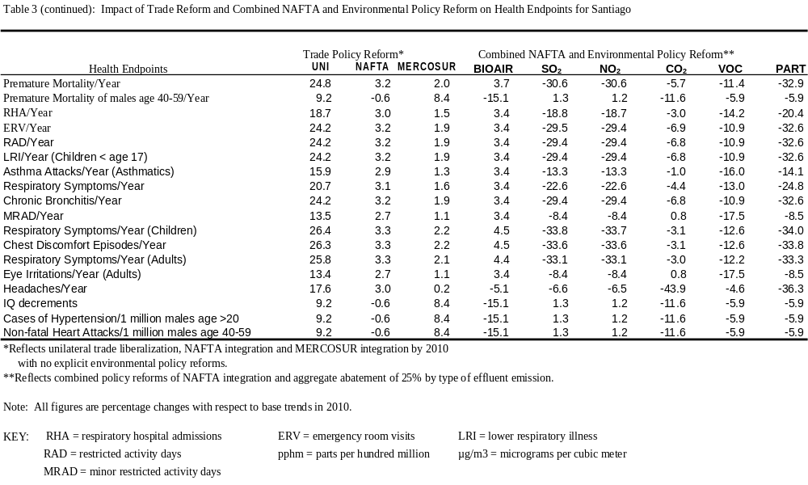

TABLE 3 (CONTINUED): IMPACT OF COORDINATED TRADE AND ENVIRONMENTAL POLICY REFORMS ON HEALTH ENDPOINTS FOR SANTIAGO. UNILATERAL TRADE LIBERALIZATION WITH AGGREGATE ABATEMENT OF 25% BY TYPE OF EFFLUENT EMISSION
Health Endpoints | TOXAIR | TOXWAT | TOXSOL | BIOAIR | BIOWAT | BIOSOL | SO₂ | NO₂ | CO₂ | VOC | PART | BOD | TSS
Premature Mortality/100,000/Year | 25.2 | 22.3 | 25.6 | 26.9 | 6.0 | 26.9 | -29.8 | -29.7 | 5.1 | 0.5 | -32.4 | 25.5 | 24.1
Premature Mortality/1 million males age 40-59 | -5.9 | -7.1 | -5.2 | -14.3 | -24.5 | 0.9 | 12.4 | 12.2 | -4.7 | -1.4 | 2.5 | -5.1 | 3.5
RHA/Year | 18.9 | 16.8 | 19.2 | 20.2 | 4.9 | 20.3 | -16.5 | -16.4 | 5.8 | -7.2 | -18.3 | 19.1 | 18.2
ERV/Year | 24.6 | 21.9 | 25.0 | 25.9 | 4.0 | 26.3 | -28.5 | -28.4 | 3.4 | 0.8 | -32.3 | 24.9 | 22.8
RAD/Year | 24.6 | 21.9 | 25.0 | 25.9 | 4.0 | 26.2 | -28.5 | -28.3 | 3.4 | 0.8 | -32.3 | 24.9 | 22.8
LRI/Year (Children < age 17) | 24.6 | 21.9 | 25.0 | 25.9 | 4.0 | 26.2 | -28.5 | -28.3 | 3.4 | 0.8 | -32.3 | 24.9 | 22.8
Asthma Attacks/Year (Asthmatics) | 15.9 | 14.2 | 16.2 | 17.3 | 5.3 | 17.2 | -10.4 | -10.3 | 7.1 | -11.3 | -11.1 | 16.1 | 15.8
Respiratory Symptoms/Year | 20.9 | 18.6 | 21.3 | 22.3 | 4.6 | 22.5 | -20.8 | -20.7 | 5.0 | -4.3 | -23.3 | 21.2 | 19.9
Chronic Bronchitis/Year | 24.6 | 21.9 | 25.0 | 25.9 | 4.0 | 26.2 | -28.5 | -28.3 | 3.4 | 0.8 | -32.3 | 24.9 | 22.8
MRAD/Year | 13.3 | 11.9 | 13.5 | 14.7 | 5.7 | 14.5 | -4.9 | -4.8 | 8.3 | -15.0 | -4.7 | 13.4 | 13.7
Respiratory Symptoms/Year (Children) | 26.8 | 23.7 | 27.2 | 29.4 | 10.8 | 28.7 | -33.3 | -33.1 | 9.3 | -0.2 | -33.1 | 27.1 | 27.4
Chest Discomfort Episodes/Year | 26.7 | 23.6 | 27.1 | 29.3 | 10.8 | 28.5 | -33.2 | -33.0 | 9.3 | -0.2 | -33.0 | 27.0 | 27.3
Respiratory Symptoms/Year (Adults) | 26.1 | 23.1 | 26.5 | 28.5 | 10.7 | 27.8 | -32.8 | -32.7 | 9.0 | -0.1 | -32.6 | 26.4 | 26.7
Eye Irritations/Year (Adults) | 13.3 | 11.9 | 13.5 | 14.6 | 5.7 | 14.5 | -4.9 | -4.8 | 8.2 | -15.0 | -4.7 | 13.4 | 13.7
Headaches/Year | 19.0 | 17.9 | 19.6 | 11.0 | -49.7 | 20.4 | 0.4 | 0.7 | -46.0 | 4.7 | -39.0 | 19.6 | -5.3
IQ decrements | -5.9 | -7.1 | -5.2 | -14.3 | -24.5 | 0.9 | 12.4 | 12.2 | -4.7 | -1.4 | 2.5 | -5.1 | 3.5
Cases of Hypertension/1 million males age >20 | -5.9 | -7.1 | -5.2 | -14.3 | -24.5 | 0.9 | 12.4 | 12.2 | -4.7 | -1.4 | 2.5 | -5.1 | 3.5
Non-fatal Heart Attacks/1 million males age 40-59 | -5.9 | -7.1 | -5.2 | -14.3 | -24.5 | 0.9 | 12.4 | 12.2 | -4.7 | -1.4 | 2.5 | -5.1 | 3.5
Note: All figures are percentage changes with respect to base trends in 2010.

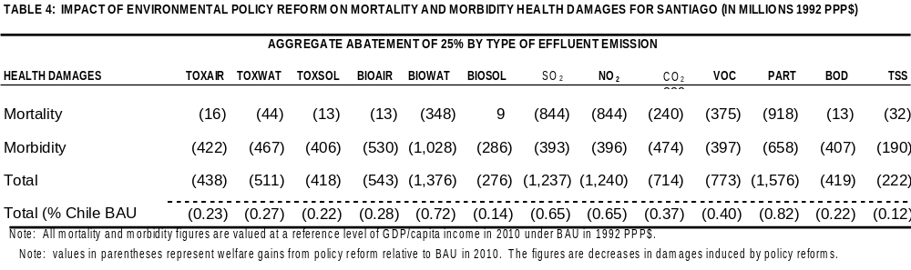
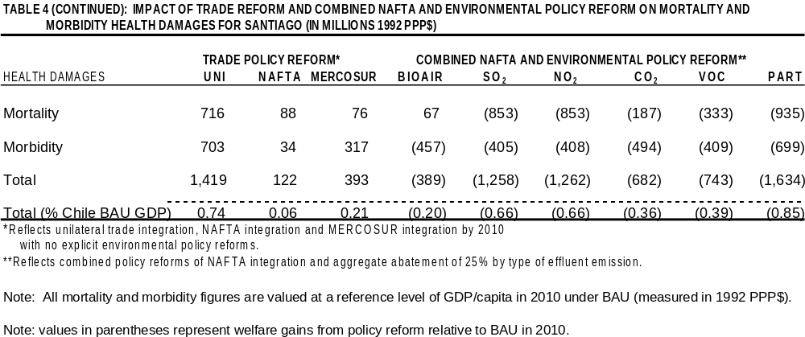

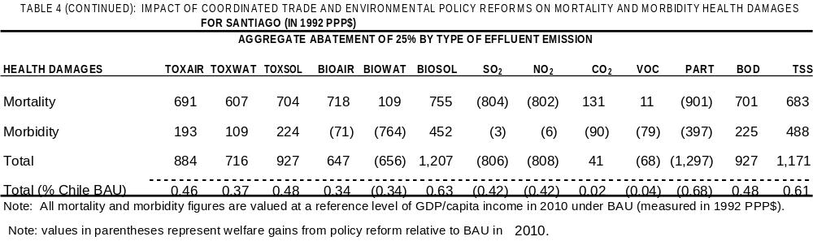

Thanks are due to Jim Chalfant, Shanta Devarajan, Gunnar Eskeland, Per Fredriksson, Eckhard Janeba, Raul O'Ryan, Randy Wigle, and conference and workshop participants at Universidad de Chile, Comision Nacional del Medio Ambiante in Santiago, Camp Resource, The NBER University Conference on Trade and Environment, and The World Bank Conference on Trade and Environment, for useful discussions and comments. The views expressed in this paper are those of the authors and should not be attributed to their affiliated institutions. Affiliations are John Beghin: Iowa State University, Brad Bowland: University of Minnesota, Sebastien Dessus: OECD Development Centre, David Roland-Holst: Mills College and CEPR, and Dominique van der Mensbrugghe: OECD Development Centre. Contact author is John Beghin (Economics, 260 Heady Hall, ISU, Ames Iowa 50011-1070, beghin@iastate.edu).
The recent empirical literature on trade and environment linkages has looked at the interaction between environmental regulation in the North, foreign investment and firms on the international division of labor and the emergence of pollution havens (Eskeland and Harrison, Tobey, Low and Yeats), and the interaction between openness and specialization, and associated pollution intensity of output and trade (Beghin et al. (1995), Birdsall and Wheeler, Grossman and Krueger, Hettige et al., Lee and Roland Holst).
For example, total suspended particulates (TSP) and respirable particulates (PM-10), ozone and CO concentrations in Santiago are in excess of established standards for several months every year (World Bank (1994)). The 1-year average concentration of PM-10 was estimated at 50 μg/m³, in Santiago in 1992, the most recent year reported in the World Bank Environmental Report (The World Bank (1994)). Comparable PM-10 measures for Jakarta and Bangkok suggest that Santiago’s PM-10 concentration is respectively about 50 and 30 percent higher than those in the two cities.
The Chilean investigation is part of the research program of the OECD Development Centre on the interface between growth, trade and the environment, with a focus on Pacific countries: Chile, China, Costa Rica, Indonesia, Mexico, and Vietnam (see Beghin et al., Lee and Roland-Holst and Dessus and Bussolo for companion papers).
Taxing all pollutants simultaneously raises difficulties. First, tracing the effect of any single tax on resource allocation becomes impossible. Second several tax combinations lead to the same decrease in all pollutants, but with different implications on sectoral allocation, consumption and trade.
We thank Randy Wigle for this cautionary note.
Our decomposition of pollution follows Copeland and Taylor and Beghin et al. (1997), which differs from Grossman and Krueger’s. The major difference resides in the technique effect. Grossman and Krueger include technical change in their technique effect; by contrast we consider movements along an iso-production surface away from polluting inputs with given technology.

