Why are the uses multiple

Forests are managed for multiple uses because multiple uses are unavoidable. Management is the manipulation of the forest to produce different mixes among the uses. This manipulation is undertaken to achieve a set of objectives. This paper is largely about the objectives of multiple-use management and how those objectives have and will change over time. The first section of the paper provides a review of recent events in the American West with an emphasis on how different objectives were imposed upon private and public forest managers. The second section discusses political economic models that could lead to these changes in objectives. The third and last section discusses changing objectives in terms of a stochastic model and the use of planning tools.
Management decides the relative importance of forest objectives. For example, the amount of water that comes from forests is not very sensitive to management. The quality of the water, however, is quite sensitive and depends upon whether or not silt is dumped into streams and whether clear cuts have effective buffers. Recreation is another form of forest use. In the United States, where the expanses of land are quite large, hikers physically cannot be excluded, so there is always some recreational use. Of course, they could be encouraged with facilities or discouraged with fences. Wildlife lives in the forest anyway. Clear cuts are a management regime that favors game while lack of clear cuts favors old-growth habitat for animals, such as spotted owls. There is no way to avoid multiple use in forests. There are, however, ways to make some uses be favored over others. Which prescriptions are used depend upon the goals for which the forest is managed.

Postwar Goals and Policies
The question in forest planning is largely which use shall be master or how to trade off one use against another. In the American West, it is politics that drives multiple-use management. These politics have had three distinct regimes in the prewar period. From about the war until the early 1980s, timber was king. There was a very large housing boom in the United States, and the forests were thought of mostly in terms of their ability to provide wood. In the mid-1980s, there was considerable concern expressed through political and legal channels for maintaining old-growth forests. In the early 1990s, there was a new regime in which the Spotted Owl was king. No longer were forests planned for timber with other uses to be handled later. Now, the forests were to be planned to maintain old-growth habitat. With this change in objectives, there were also some management changes. The tools that are used have adapted to the politics, and the managers and planners have adapted to the politics. Viewing this over the long run, one often wonders whether or not the planner matters here.
The early postwar period was characterized by a political agreement that timber was king and that the purpose of the forests was to be, in the words of Gifford Pinchot, the first forester in the United States: tree farms. During the early period, informal tools and discretion, i.e., professional judgment of foresters, were the most important determinants of how the forests were used.
In this heyday of old-style planning and up to approximately 1990, the planning job could be characterized in a very simple way. There was a planner, and the planner was a professional forester and often a forest supervisor. The planner had intimate knowledge of the resource—knowledge that was not held by outsiders or easily written down. The planner’s job was to figure out what the owner, in this case, the United States, wished to be done with the forest. It was not necessary to undergo much of a planning or preference elicitation exercise to determine the preferred use. Indeed, there were other uses, such as recreation, but timber seemed to be the overriding consideration. The owner also supplied the capital, and the planner needed to know how much money the owner would supply to actually cut the forest down as national forests were run as money-losing operations. The planning job was classic. The planner determined the preferences and budget and then found the best plan among the feasible plans. This type of exercise was easily amenable to mathematical programming formulations. But, in the early days, there was no need to do so. Professional judgment would have sufficed.
The catch in this idealistic planning algorithm was that an owner was needed. A close substitute would be a wide consensus on the appropriate goals and a political willingness to let the planner determine the goals within that consensus. In other words, the American people had faith in the U.S. Forest Service (USFS). Before approximately 1970, management of forests was not so contentious and these conditions were certainly true.
The Multiple Use Sustained Yield (MUSY) Act of 1960 was a high point of the influence of the USFS. The Act codified what the USFS was doing anyway and named a set of multiple uses: recreation, range, timber watershed, wildlife, and fish. The Act stated that no specific use could predominate and that a high level of annual output should be maintained without impairment of the productivity of the land. This was very broad guidance, and it gave the Agency a considerable amount of freedom. The USFS could operate, more or less, as it wished under MUSY of 1960. This was so simple was because there were substantial areas that were untouched by cutting. The last frontier had not been reached.
Though not in the Act, but very much in USFS literature, were the Agency objectives. One was community stability—thought to be jobs. Conveniently, this is coincident with no profits. Supply of fiber (i.e., wood) was another important objective. In recreation, big game and fish (both of which are hunted) were predominant. Scenic drives were also mentioned quite often. And hiking had not yet come into its own. These objectives were harmonious: More wood was more jobs and open forest, and more open forest was more game. There was very little conflict.

Wilderness
The beginning of the end for this period was the Wilderness Act of 1964. Indeed, the USFS had designated wilderness on its own. It saw wilderness as a worthwhile use of its lands but mainly lands that were on high and inhospitable terrain. The USFS did not appreciate being told that these areas were off limits to timber and other activities by law. In addition, they were not pleased when they were told to study additional lands for inclusion in the wilderness system. These large single-purpose reserves went against the multiple-use grain. Perhaps, more important, the planner would not be able to decide which lands to reserve. Congress was now taking an active hand in land-use management.
The transformation of the management of the national forests came about by three acts and were not considered radical: National Environmental Policy Act (NEPA), Resources Planning Act (RPA), and Endangered Species Act (ESA).
The NEPA simply states that, before a major federal action can be taken, the Agency must get public comment on issues to be considered; make a plan [Environmental Impact Statement (EIS)] and several alternate plans, including a no-action alternative; get public comment on the plans; and choose a preferred alternative. This was not considered radical legislation but merely a way to require the Agency to carefully think about its actions. The Agency was, under this law, going to retain its discretion to choose its preferred alternative.
The RPA of 1974 was, again, in this vein although the idea was to produce plans specifically for national forests. It was a top-down act starting at the national level where goals would be set. These targets would then be sent to regions and, ultimately, to forests for fulfillment. The forests were to produce plans to meet their parts of the target. The Act was a way for the USFS to get long-term agreement with Congress because these were five-year plans. Presumably, goals would be made clear and Congress would appropriate the money to meet these goals. For the forest industry, it also gave a clear mandate to produce wood—something that the Wilderness Act surely had not. The RPA did not work because people did not agree on the goals. Environmentalists wanted more wildland than the USFS was planning to provide. The conflict was forced to a head by a lawsuit over clear-cutting in the Monongahela National Forest. The result was adverse to the USFS. That decision resurrected language in the Organic Act, which is 100 years old, that made it necessary to consider each tree before cutting. In effect, it made the preparation of forest sales throughout the United States far too expensive to be carried out. There was a very clear need for new legislation that would repeal the offending provision in the Organic Act.
The National Forest Management Act of 1976 was a political compromise. In the markup of that Act was the Sierra Club and the timber industry, and they both gave their assent. There were two key elements in the Act aside from the repeal of the offending clause. The first requirement was that the forest be managed for nondeclining flow. This was meant by the environmentalists to conserve old growth although even a cursory analysis would show that it would only delay the day when the last bit of old timber was cut out. The second requirement was that trees were not to be cut until a majority of the stand had reached the culmination of mean annual increment (CMAI). This was meant to put teeth into the idea of sustained yield. Stands would be allowed to reach a reasonable age before they were harvested. The Act, however, is ecological meaningless. The trees at CMAI are still too small to support an old-growth ecosystem or even a very diverse forest.
The ESA, again, was thought to be innocuous. It stated that the Fish and Wildlife Service would have to produce a list of animals that were either in danger of being extinguished or threatened with being extinguished. Any animal on that list could not be taken even on private land. The word “take” was later construed to include the removal of habitat. The Act specifically required a list of the habitats to be protected in order to keep the animal in existence. This Act, more than any other, put the whip hand in the environmentalists’ hands. It has also spawned a very complicated legal problem regarding taking. When is it that the regulation of private property becomes the confiscation of private property? Takings, under the U.S. Constitution, obligate the government to pay for the property. Indeed, this is the major issue in the management of private forest land in the West.
Together, these acts provided for participation and litigation. The RPA was radical in that it provided for interdisciplinary teams to make the forest plans. At the beginning, it was unclear whether or not these teams or the forest supervisors would have the final say. Later, the regulations made it clear that the forest supervisors would have the final say. There was a period for public comment, and the public comment needed to be recorded and taken seriously. In addition, all actions that were taken needed to be fully disclosed to the public. The ESA gave the public the right to sue to protect the endangered animals. These acts gave the public the ability to see the inner workings of the Agency, including its mistakes, and science that could be debated if not overturned and to sue, based upon the need to protect the animals, or perceive mistakes in the procedures used by the USFS.
Under NFMA and RPA, it was formal planning for multiple use, and it was carried out by linear programming. It had been known for some time that forests could be programmed in this manner. Daniel Navon wrote an early code for this purpose although it was the model of Johnson and Scheurman (1977) that is widely used. The basic idea was to maximize the present value of timber subject to CMAI, nondeclining flow, and other constraints. Other constraints included a need not to destroy the habitat of endangered species—the Spotted Owl, of course, being the most famous of the species.
The simple forest-planning algorithm is the well-known Johnson and Scheurman algorithm. Figures 1 and 2 include the mathematics. Here, there are many different sites labeled “j” and many “birthdays” for stands labeled s. The t is calendar time, so h^{j}(t, s) is the amount that is harvested from site j at time t for stands that were first planted in year s. Similarly, D^{j}(t - s) is a volume table, giving the volume per acre of function h. Letting v be cut, it is simply the sum over sites and birthdays of volume per acre times acres harvested. In the simple model, the present value of P times V can be maximized. The constraints are the biology, nondeclining flow, and CMAI. The biology is just conservation of acres. Initial acres are the same as acres cut over all time. Therefore, any acres that are cut are replanted; they regrow and then must be cut as well. It is convenient to keep track of what is left standing because what is left standing is habitat for animals, particularly, old-growth habitat, which is denoted by W. Berck and Bible (1984) provide the mechanics of expanding the Johnson and Scheurman model to the case where W is accounted for. To give more meaning to the model, one must decide what types of sites one has. Traditionally, of course, it would be different species and site classes. Less traditionally, it would be critical locations. Land near streams or in visual buffers could simply be assigned another site class and prohibited from certain treatments. These would be constraints, such as “do not cut type j” or “keep n percent of the forest at some age or above.” These are all constraints on forest stock or W. Treatments would be added as well, e.g., commercial thinning and precommercial. It is the thinning treatments that have become controversial in the case of the Northern Sierras.
The traditional problem with this mode of planning was that the plans on the computer did not correspond very well to the plans on the ground. This was described as finding the cut. The plans were not spatial. They simply stated that a certain amount of acres of a particular forest type needed to be cut in this period. The foresters still had to find a specific parcel to cut. It was difficult to see what the cumulative effect of their decision would be because mapping technology was poor. Taking one of these plans and mapping out what it would mean over 100 years would be a tedious exercise. Taking 50, 60, or 100 plans that were made in the process of reaching a preferred alternative was an impossible exercise. Hrubes (1981) wrote a Berkeley dissertation on the problem of finding the cut. What he found was that the cutable land base was much smaller than the planned land base. Some of the reasons, in those years, included streams, Indian burial grounds, and needed habitat. The difference between the truly cutable land base and the computer plans was only discovered when one went out to find the cut.
The second class of problems with planning, which remains to this day, was called the allowable cut effect. Consider a forest with both old growth, which is valuable, and high-altitude, unroaded, low-density stands, which are not valuable. A profit-maximizing, nondeclining flow plan would include cutting the valuable stands in the early period and cutting the unvalued stands toward the end of the planning horizon. As long as equal amounts were cut both at the beginning and end and in between, the nondeclining even-flow constraints would have been met. This process would be fine except, after the old-growth was cut, the forest would be replanned. When the forest was replanned, a present-value maximizing plan would not specify cutting the remote unprofitable trees. Thus, the second set of planning done after the valuable old growth was cut would call for a lower yield than the first set of planning. Under nondeclining even flow, the cut would, in fact, decline. The USFS was perfectly satisfied with the process. A great deal of wood would be available if plans were held with commitment. Environmentalists detested the process. They preferred to see the old growth remain, and the allowable cut effect caused the old-growth to be cut down sooner. This fundamental problem of lack of commitment to plans persists to this day in American forest planning.
Another problem was that forest plans took a great deal of time. At the beginning, as an observer, I believe that they took a great deal of time because the planning-requirements process was difficult. In hindsight, it does not appear so innocent. The old plans, before NFMA, were used during the waiting period. The old plans called for a great deal more cutting of timber than did the NFMA plans. Once it was clear that new plans would call for less timber, industry and their political allies, particularly the Reagan Republicans, did not want the plans to be final. Environmentalists obliged them by obstructing plans with lawsuits.
The Plumas National Forest map (Figure 3) depicts an actual plan made in 1988. One-fourth of the Forest is shown. Except for the white area, logging was off limits. The Spotted Owl habitat is shown by black dots, and the Goshawk habitat is shown by triangles. As the Spotted Owl issue went forward, the amount of terrain taken by the Spotted Owls went from the dots that you see to a greater portion of what was left white. Indeed, by the end, very little was left that could be cut.

Spotted Owls
The Spotted Owl is an owl that lives in older trees although that is somewhat debated in California where they have been found living in trees of much younger age. In 1986, well before the Spotted Owl was listed as a threatened species, the USFS drafted an EIS on the Spotted Owl that would lead to a 5 percent reduction in timber cut. The final EIS in April, 1988, called for slightly more cutting and is reflected on the Plumas map. This level of protection was not enough to comply with the law to protect the Spotted Owl. In March, 1989, Judge Dwyer issued an order that restrained the USFS from offering 139 planned sales, which was, essentially, its entire program in the West. In June, 1989, the Spotted Owl was proposed as a threatened species. In June, 1990, it was listed. These actions were forced by lawsuits. The 1990 listing was defective in that it not include a listing of the critical habitat of the Spotted Owl. The ESA states that a list of the habitat to be protected in order for the animal to survive must be published in the Federal Register. The Fish and Wildlife Service had declined to do that.
Congress became quite upset with the situation as there was no timber being cut and that meant, in the states of Washington and Oregon, there was considerable dislocation. Congress was no stranger to direct control of the forest. They had been using the notion of allowable sale quota as far back as Carter, a Democrat and supposed friend of the environment, who asked the USFS to massively increase the amount of timber cut to provide for a housing boom. Again, in approximately 1984, Congress intervened, this time, to save the timber industry. In the late 1970s, bids for federal timber, sold on five-year contracts, had large inflationary expectations built in. Restrictive monetary policy dramatically lowered the inflation rate, and the companies found that they had contracted to pay more than the timber was worth. In 1984, Congress released them from their obligations without full penalties. It was no surprise in 1989 that the Hatfield-Adams bill directly prescribed the amount of timber to be sold for 1989-90. It prescribed it at 9.6 billion board foot. It streamlined the appeals process; made the EIS not subject to immediate judicial review; prohibited the use of temporary restraining orders or preliminary injunctions on fiscal, 1990, timber sales; set very strict deadlines for judicial review; and allowed the use of special masters to further speed up the court system. In short, Congress said that the USFS must cut more timber than the ESA and the USFS’s plans would permit.
The Act also called for a study of the now pesky Spotted Owl. The future chief of the USFS, Jack Ward Thomas, was one of the leading members of Interagency Scientific Committee that produced this study in 1990. This study called for reducing harvests in the owl area by 30 percent to 40 percent. This was a far cry from the Hatfield-Adams congressional response that harvests were to be kept up at any cost. In order to comply with the orders of the federal courts, the Fish and Wildlife Service, under the Reagan Administration, which was extremely anti-environmental, was forced to comply with the ESA and list critical habitat for the Spotted Owl. It used the report by Thomas and, basically, enshrined those recommendations in law, listing as habitat 11.6 million acres in which 3 million were private. At this point, the Spotted Owl had moved from being a pest or a minor issue in multiple-use forestry to being the use for these forests. There was, indeed, a small counterattack by the Reagan Administration in which several Bureau of Land Management sales, not nearly as many as they had hoped, were exempted from the ESA by a group called the God Squad. The God Squad is a common parlance for the group that is permitted to allow a species to be extirpated. This being the federal government, one study followed another. The next study was known as FEMAT. Again, Thomas was one of the leading blights. The study gave many possible options for managing the forests in the West and decided in favor of option nine in response to the President’s summit in April, 1993. In option nine, timber cut would go to 2 billion board foot, then 1.7 billion board foot, and then decline to nearly 1 billion board foot in the long run. The average was 1.2 billion board foot over 10 years. That is approximately a 90 percent reduction from all-time highs and, certainly, about a 90 percent reduction from the Hatfield-Adams congressional mandate. The FEMAT went further. It called for an ecosystem management plan for holistic, adaptive planning of the national forests. This was to be something new and different. Adaptive management meant that there was to be experimentation and that local communities and agencies would have some control of the experimentation. Of course, FEMAT option nine still protected the Spotted Owls.
President Clinton’s Forest Plan is, basically, option nine and calls for less timber and more attention to the ecosystem. The President went even further in his restructuring of forest priorities, he replaced the planner. Jack Ward Thomas, the biologist, and now Mike Dombeck, a biologist, became head of the forest service. The timber beast was no more. The planning process is also being replaced as this talk is being written. It appears very likely that the linear program that we know as Forplan will be replaced. It may be true that there will be no role for programming. It is very certain that the use of Geographical Information Systems (GIS) will be required.
Congress, being Republican and not environmentally inclined, objected strenuously to the President’s Plan and passed what was known as the Salvage Ride. This bill was in effect for two years and was a response both to destructive fires and to the very strongly declining cut. Under the Salvage Ride, the USFS was to double the cutting of dead and dying trees in national forests over the next 18 months. It had always been policy to sell green trees with dead and dying trees so as to cause the dead and dying trees to pay their way out of the woods. Thus, the salvage rider actually called for the cutting of green trees as well. The Agency would be unhindered by the ESA and other laws protecting wildlife, and timber sales would be exempt from court challenge during this time. Clearly, Congress was in the driver’s seat again and, by using the Appropriation Bill, had directly countered the President’s Forest Plan and the current plans of the USFS.
The short summary of the planning objectives on public land is a trend toward preservation, and against timber, on which is superimposed a great vacillation of purpose. The story of private lands continues to unfold.
In Northern California, there is another animal that is worth mentioning—the Marbled Murrelet. They were listed as threatened in 1992. They nest in older redwood trees. In addition to the murrelets, in California, various species of trout and salmon are listed as endangered. What has caused the most trouble is that these endangered species live on private land as well as public land.
The Headwaters Forest and the area around it are very controversial. It involves the nesting areas of the murrelet and the density of old-growth redwood. The densest part is the Headwaters Forest, which is currently owned by the Pacific Lumber Company and is being sold, as I speak, to the United States and the state of California. The Headwaters Deal is complicated. One part of it is simple: The United States and the state of California buy the forest for $380 million. It becomes complicated when, in exchange, both entities agree to a habitat conservation plan for the remainder of Pacific Lumber’s holdings. In effect, by selling the Headwaters Forest to the State at less-than-market value, Pacific Lumber has been allowed to file a favorable habitat plan for its remaining land and to be free of hindrance by the ESA in its other woods. Of course, environmentalists complain bitterly about this and the Plan may fall apart. Should the purchase not be consummated and the habitat conservation plans not be approved, Pacific Lumber will sue the United States and the State and claim that they have been allowed no economic use of their property. They may well win such a lawsuit, with the effect that the ESA would no longer be enforceable on private land. The goals on private lands are out of the control of the private landowners and are very much a matter of negotiation and litigation.
Another piece of the Clinton Plan looks like a stakeholder process. The idea is that the politicians would get interested parties into the room, and these parties would bargain with each other. Of course, they would be bargaining in the shadow of the law. Then, the parties would reach an agreement that the politicians would be able to implement without fear of political reprisal.
An example of the stakeholder process is the Quincy Library Group and the resultant proposed legislation. Local environmentalists and the local timber dominant firm, Sierra Pacific Industries, are trying to get Congress to accept their view of how the area around Quincy, which is just off of our map of the Plumas National Forest, should be managed. The local view had a lot to do with jobs, timber, and fire. It cannot be emphasized how great an effect large forest fires have had on the people who live outside of the cities of California. The National Conservation organizations were not well represented, partially because they did not believe that anything that could happen in a library in Quincy would have anything to do with what happened in Washington where they live. The big issue, here, is forest condition. The locals want thinning. They want to reduce fire risk, and they want the volume of the lumber produced by the thinning, particularly, jobs. The thinning regimes would be an experiment in adaptive management if the bill were to pass. Again, there is a conflict of goals. Local “stakeholders” have a very different view than national organizations, and it is unclear who will prevail and for how long.
With that background, I would like to try to make some economic sense of this record of multiple use and find some of the implications for planning.

Stock, Flow, and Jobs
There is a new emphasis on stock. The Agency and Administration have gone over to the view that it is protecting wildlife; reducing susceptibility to fire; and creating healthy, natural, or diverse forests, possibly getting them back to pre-European conditions, that are the real goals. These goals are quite at loggerheads with the Republican and congressional points of view, which emphasize the flow of services, particularly, jobs and timber.
Of course, jobs make much better politics than timber. Sample and Le Master (1992) looked at four studies of how many jobs would be lost. This was before the full effect of the owl was actually known. Their study found that thousands of jobs in the pacific northwest would be lost, and those job losses were about two parts from the Interagency Scientific Committee recommendations on the owl and, perhaps, one part from either reduced harvests from federal forest plans, technological change, or any of these other possibilities. There are many problems with this point of view. A basic problem is that it is always stated in terms of jobs, and it should be stated in terms of job years. When old growth is cut down, it can be done only once. Therefore, jobs per board foot make some sense, but they need to be spread out over many years. There are other technical problems. Jobs are, of course, a demand for a factor of production, and factor demands are unlikely to be linear in output. They are also unlikely to be constant over time because of technical progress. Another area of contention is indirect jobs. The standard procedure is to see in an input/output table how many additional jobs there would be if there were one additional basic timber job. If this calculation is done, two or three jobs is the outcome. Done more carefully, according to Stewart (1993), a lower number is derived because taken into account are the number of jobs that have been caused by, for example, transfer payments for retirees that have no part in the productive process. My coauthors, Chris Costello, Louise Fortmann, and Sandy Hoffmann, and I have examined the same problem using regression techniques. What we found is extremely different. We found that an additional job in the timber industry costs jobs in the other sector. That is, in Northern California, if one has one more job in the timber industry, after two years, one will only have 80 percent of one job left and that the nontimber sector will have shrunk. I do not believe, based upon this work, that timber drives the economy, at least in Northern California counties, or that jobs are anything more than a stalking horse for industry profits.

Political Economy
An economist making sense out of politics can be done in four different ways: a game, median voter theorem, money and votes, or a political business cycle.
As a game, there would be two players—an environmentalist and a timber beast. The condition of the forest, say, the rotation age, and how much of the forest is used for timber as opposed to environment would be the issues of concern. The player interested in timber, the timber beast, would like to choose his rotation age to maximize the value of his return given the interest rate and a chance that some of his wood would be taken away from him and used for environmental purposes. As the chosen rotation age goes down, the chance that the government expropriates the property for environmental uses rises. The environmentalist lobbies for reservations of timber, which are expropriations. Lobbying is costly. The timber beast prefers a low rotation age while the environmentalist prefers a high rotation age. If this problem is worked out, and it has been worked out by Chris Costello, it shows that the more aggressive the environmentalist the more the timber beast will be likely to choose a low rotation age. Therefore, the condition of the woods will deteriorate as the probability of them being taken for environmental purposes increases.
In 1976, another then student, Haim Shalit, in an unpublished paper, looked at this problem as the median voter theorem. There are a number of technical assumptions that one would need to make, but the answer is that the USFS will do what the median voter prefers. A generalization is Peltzman’s (1976) model in which both money and votes matter. Here, the timber beast wants the government to cut timber. Cutting, however, is unpopular with the voters. The timber beast can remedy this by donating money for political campaigns. Voters respond to political campaigns. As long as the timber beast gives the government (i.e., politicians) enough money so that they can be reelected, they will cut the timber against the will of the environmentalist.
Rogoff (1990) is the author of choice regarding the political business cycle. Presidents last only four years until reelection and congressmen, two. That gives them very short time horizons and induces a political business cycle. The idea is to take the downturn at the beginning of the term so that the recovery will be well underway by reelection. For instance, the Senator from Washington, Hatfield, needs rural votes. If he can shift timber harvest to the present, then there will be good times in the State and he will, most likely, be reelected. The fact that there will be a severe restructuring later in his term (six years), or even in the term of someone else, is really of no consequence to him.

Consequences: A Stochastic Model
A different view of the problems of the planning process and why multiple use is contentious would be in a simple stochastic model. I have in mind Granger’s (1988) model of a stochastic objective function. In Granger’s model, there are goals, in our case, timber and owls, which will be called GT and GO. And there are achievements, T and O. I have discounted these at a rate of interest and summed over time. Figure 5 has the formal model. The b is the price of owls relative to timber. The constraint set is that of the biology, and this would work perfectly if the constraint were linear, which they would be if the Forplan were used. Recent politics would be, in a sense, a change in the goal for owls. The goal was low and now it is high or the goal for owls and timber can both change. Recent history represents not just changes in the goals but an oscillation in the goals. The ESA, Congress, and the President all win for awhile.
There are, of course, real stochastic elements, such as fire, which stochastically assign acres to new “birthdays” without the benefit of harvests. A piece by Johnson et al. (1996) does approximately this. Trees do not always reach the one-year-older age classes, e.g., Bud Worms may destroy them. And the relation between owls and habitat has a random element. Indeed, there is no certainty whatsoever after 30 years of what the relation would be between the prescriptions made and the number of owls that would be there. The idea that these are, indeed, stochastic equations is quite realistic.
The horror of the stochastic model is that, since the goals change with the political winds, so will the plans. The plans will be, in this model, a linear function of the goals. Therefore, whatever type of random fluctuations the targets have, the goals will have the same fluctuations.
The implications for planning are simple. The planning exercise will be done and redone. There will be no commitment to carry out the plans. They will shift, for awhile, with the political winds. Old-growth dependent species are on a one-way trip. Once the habitat goes, it does not matter how high the goal is set in later plans. It cannot be brought back. In this type of model, there will be endless plans to save this species, and they will lose out one piece at a time. The planner will look like a fool.
The new planning environment for multiple use also reflects the primacy of the biologist. Since the day when the Interagency Scientific Committee and Thomas became the important elements in Western forest planning, the biologist has, quite literally, ruled the roost. Biologists will do their planning with the tools that are amenable to them. In this case, they would be mapping tools because biologists wish to see how different areas where their animals live relate to other areas. They will plan the condition with these mapping tools to get the forest condition that they want although they will run endless simulation models to show how the forest condition will relate to the animal populations. These plans will, ultimately, be made “by eye.” What is leftover for optimization is nearly nothing, and the traditional planner will find that he has a very minor role.
In short, a GIS that is run by biologist planners, with an interest in planning forest condition or stock, will drive whatever is left of traditional programming-type planning and not vice versa.

Figure 1

SimpleForest Planning
Type of Site, j

Many “birthdays”
h^{j}(t,s)
t is calendar time
s is birthday of stand
h is acres harvested
v(t) is cut at t
D^{j}(t-s) is volume per acre
v=∑_{j} ∑_{s} D^{j}(t-s) h^{j}(t, s)
Max present value
of P times V
s.t. biology
v(t+1) ≥ v(t)
t-s > CMAI or h = 0

Figure 2

Biology

Initial Acres = Acres Cut over all time

A^{j}(s) = ∑_{t} h^{j}(t,s)

W is what is left standing

w^{j}(s,t) = A^{j}(s) - ∑_{t} h^{j}(t,s)

or =∑_{s} h^{j}(t,s) - ∑_{a} h^{j}(a,t)

Cut acres regrow and are recut

∑_{s} h^{j}(t,s) = ∑_{a} h^{j}(a,t)

Figure 3
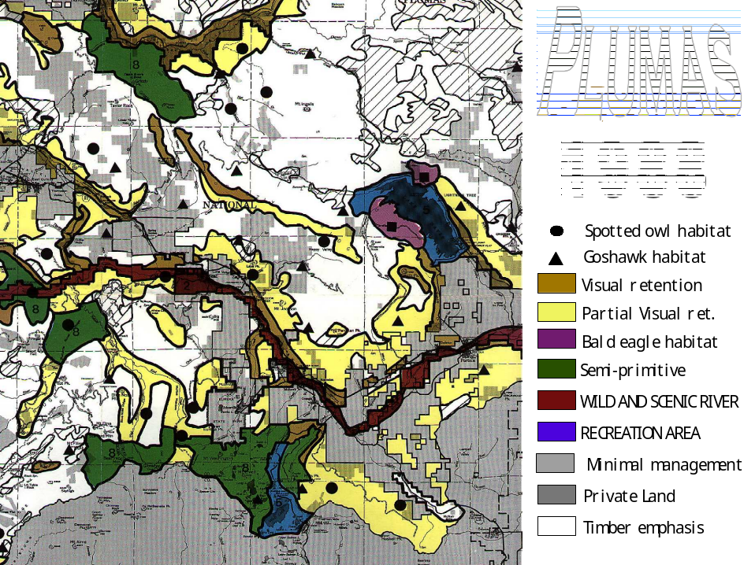
Figure 4
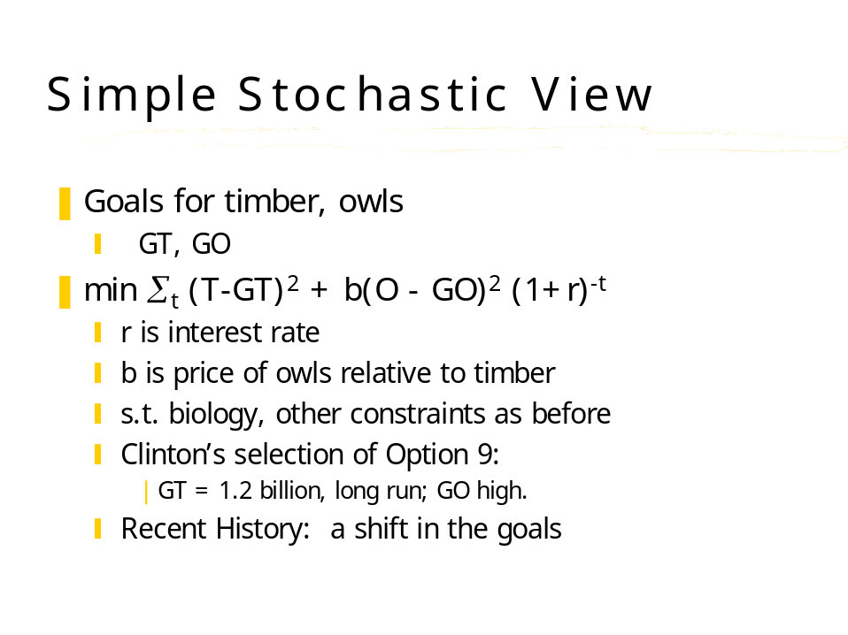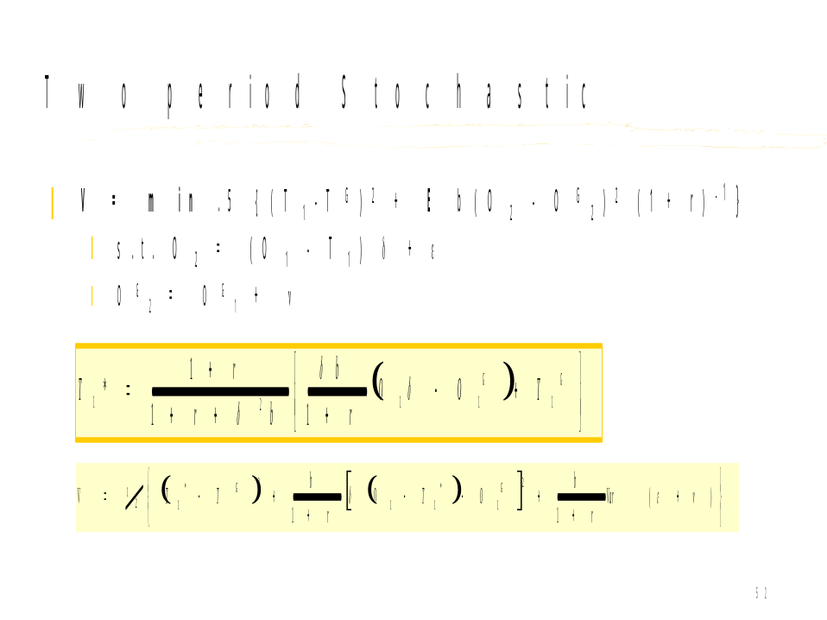
References

Berck, Peter, and Bible, Thomas. "Solving and Interpreting Large-Scale Harvest Scheduling Problems by Duality and Decomposition." Forest Science, Vol. 30, No. 1 (1984), pp. 173-182.

Granger, Clive. “Causality, Cointegration, and Control.” Journal of Economic Dynamics and Control, Vol. 12 (1988), pp. 551-559.

Hrubes, Robert John. “The USDA Forest Service in the Environmental Era: Institutional and Programmatic Change,” 1981.

Johnson, K.N., and. Scheurman H.L. “Techniques for Prescribing Optimal Timber Harvest.” Forest Science Monograph, No. 18 (1977).

Johnson et al. In “Sierra Nevada Ecosystem Project Final Report to Congress: Status of the Sierra Nevada.” Davis: Centers for Water and Wildland Resources, University of California, 1996.

Peltzman, Sam. “Toward a More General Theory of Regulation.” Journal of Law and Economics, Vol. 19 (1976), pp. 211-240.

Rogoff, Kenneth. “Equilibrium Politician Budget Cycles.” American-Economic-Review, Vol. 80, No. 1 (March, 1990), pp. 21-36.

Sample, Alaric V., and Le Master, Dennis C. “Economic Effects of Northern Spotted Owl Protection.” Journal of Forestry, Vol. 90, No. 8 (August, 1992), pp. 31-35.

Stewart, William C. “Predicting Employment Impacts of Changing Forest Management in California.” Berkeley, California: University of California, Berkeley, 1993.

Yaffee, Steven L. The Wisdom of the Spotted Owl: Policy Lessons for a New Century. Washington, D.C.: Island Press, 1994.

